A LOVE FOR LIFE BOARD OF DIRECTORS

Christine Edmonds
President

Christopher Edmonds
Secretary

Patricia Cuddy
Treasurer

Patrick Edmonds
Director

Tricia Linkenheimer
Director

Bill Sweeney
Director

Andrea Vecchio
Director
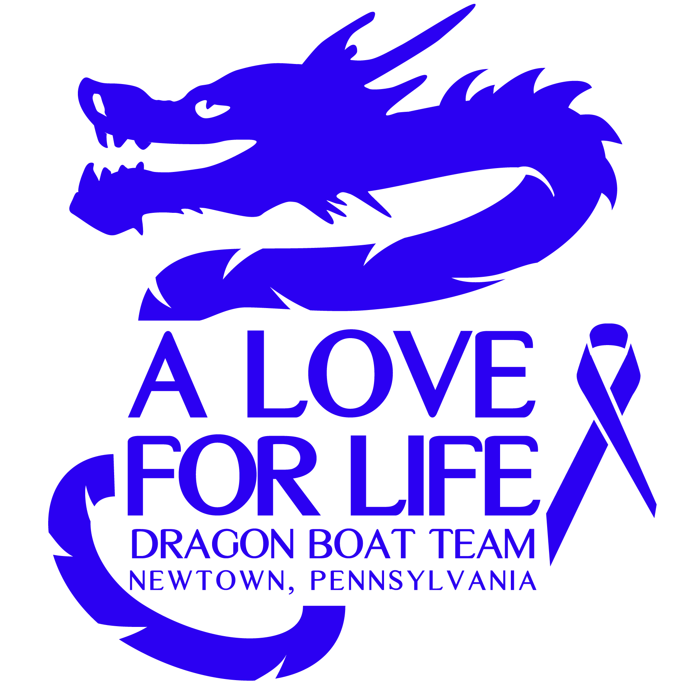

A Love for Life is a charitable organization, founded in honor of Kevin Edmonds and his sister Nora. Each was diagnosed with pancreatic cancer at age 49 and died at 51. Though this seemed far too fast, and we would have liked more time together, we still consider ourselves lucky. The average survival rate for stage IV pancreatic cancer is a little over 6 months. We want to help change that number.

Last year, shortly after Kevin died, 22 of his friends formed a Dragon Boat team in his memory and competed in the Philadelphia Dragon Boat competition. This year, we have 5 teams (over 110 participants) signed up. The race will be held on the Schuylkill River on October 5th. Approximately 20,000 people attend the all-day event.

The Abramson Cancer Center at the University of Pennsylvania in Philadelphia is at the forefront of pancreatic cancer research. 100% of the money we raise will go to a dedicated research team there. We hope your company will consider supporting our efforts.

Details of the various sponsorship levels are listed on our website. We are also happy to accept any donation of any amount that you wish.

Sponsorship Levels:
____ Boat Sponsor ($5,000)
____ Gold ($1,000)
____ Silver ($500)
____ Bronze ($250)

(If you would like your company logo on our T-shirts, deadline is September 5th)

All donors at any level will be featured on A Love for Life website and Facebook page. Take a moment to read more about our organization at: www.aloveforlife.us

Thank you very much.

